# **Name: Abdurrahman Qureshi**

# **Roll No: 210451**

Practical No: 3

**1) EXTRA - WAP in java to check if the given number is a leap year**

**CODE:**

import java.util.Scanner;

public class EXP3LeapYear {

public static void main(String[] args) {

Scanner sc = new Scanner(System.in);

System.out.println("Enter the year");

int year = sc.nextInt();

if (year % 400 != 0) {

if (year % 100 != 0) {

if (year % 4 == 0)

System.out.println(year + " is a leap year");

else

System.out.println(year + " not a leap year");

} else

System.out.println(year + " not a leap year");}}}

**OUTPUT:**

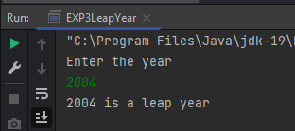

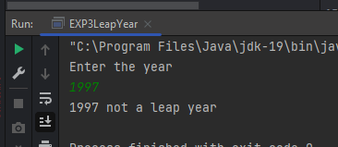

**2) EXTRA - WAP in java to Greatest Of three using logical operators**

**CODE:**

import java.util.Scanner;

public class EXP3LogicalOperator{

public static void main(String[] args) {

Scanner sc= new Scanner(System.in);

System.out.print("Enter value for A: ");

int a = sc.nextInt();

System.out.print("\nEnter value for B: ");

int b = sc.nextInt();

System.out.print("\nEnter value for C: ");

int c = sc.nextInt();

if ((a > b) && (a>c) )

System.out.println(a + " is largest");

else if ((b > a) && (b > c))

System.out.println(b+ " is largest");

else

System.out.println(c+ " is largest");}}

**OUTPUT:**

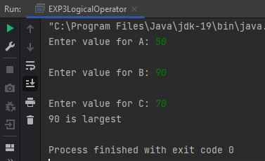 -

**3) EXTRA - WAP in java to check for odd or even number is entered**

**CODE:**

import java.util.*;

public class EXP3OddoEven {

public static void main(String[] args)

{

Scanner scanner = new Scanner(System.in);

System.out.println("\nEnter an integer:");

int num = scanner.nextInt();

if (num %2 ==0) {

System.out.println(num + " is even");}

else{

System.out.println(num + " is odd");

}}}

**OUTPUT:**

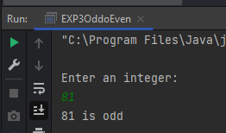 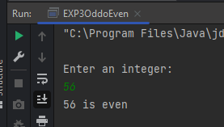

**4) EXTRA - WAP in java to check if signs are same**

**CODE:**

import java.util.*;

public class EXP3OddoEven {

public static void main(String[] args) {

Scanner scanner = new Scanner(System.in);

System.out.println("\nEnter an integer:");

int num = scanner.nextInt();

if (num %2 ==0) {

System.out.println(num + " is even");}

else{

System.out.println(num + " is odd");

}}}

**OUTPUT:**

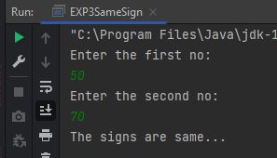 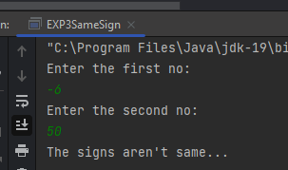

**5) EXTRA - WAP in java to check for divisibility of 6**

import java.util.*;

public class EXP3Div6{

public static void main(String[] args) {

int n = 12;

System.out.println("Enter an integer: 12");

if( n % 2 == 0 ){

if(n % 3 == 0){

System.out.println("It is divisible by 6");}}

else

System.out.println("No is not divisible by 6");}}

**OUTPUT:**

